|  |
| --- |
| 新东方在线英语学习 |
| 新概念 2 册 |
| Lesson29 |



扫一扫。更多有趣的英语资讯。

|  |  |  |
| --- | --- | --- |
| 1. taxi | n. 出租汽车 | **Lesson 29 单词讲解**  BrE |
| cab  2. flat | n. 公寓房 | AmE  BrE |

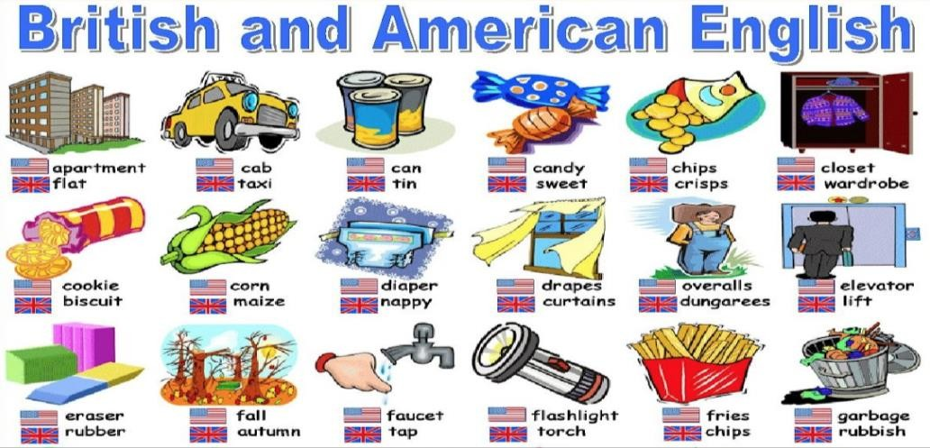apartment AmE



1. lonely adj. 偏僻的，人迹罕至的

感到孤单寂寞的

1. Welsh adj. 威尔士的

Wales n. 威尔士

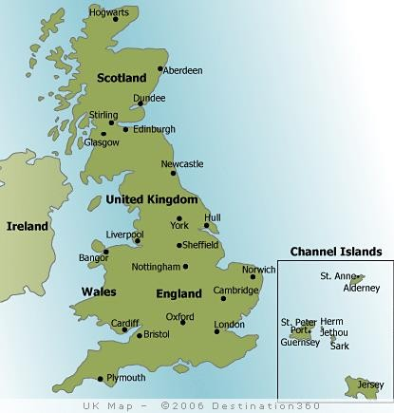

1. block n. 一座大楼

a block of flats / apartments a flat block

an office block a tower block

traffic block / jam

# Key points:

**复习现在完成时**过去分词 作定语

# Lesson 29 课文&语法讲解

* 1. Captain Ben Fawcett has bought an unusual taxi and has begun a new service.

现在完成时

形式： have/has + done

用法： 现在的之前

* 1. The “taxi” is a small Swiss aeroplane called a “Pilatus …”.

过去分词作后置定语，修饰名词

a used car

water, or



wasted time

a ploughed field

a deserted car park

a woman called “Dragon Lady”

3. The most surprising thing …, however, is that it can land anywhere : on snow,

even …

1. The most surprising thing … is that it can land anywhere

上面那句话是表语从句 看that前面那个词是什么 如果是及物动词则是宾语从句

如果是系动词则是表语从句

表语从句

1. Captain Fawcett’s first passenger was a doctor who flew from Birmingham to a lonely

village …

定语从句

fly flew flown from … to …

1. Since then, Captain Fawcett has flown passengers to many … places. He has lived in Beijing since 1993.

for 20 years.

He has lived in Beijing since he was born.

1. Once he landed on … a block of flats and on another occasion, he landed in a deserted car park.

once … and on another occasion … 一次 另一次

1. Captain Fawcett has just refused a … request … refuse a request

现在完成时

have/has + just + done

already ever never

1. The man wanted to fly to Rockall, a lonely island in the Atlantic Ocean, but Captain … did not take him because the trip was … dangerous.

同位语

… but … because …

# Lesson 29 知识拓展

Since then, Captain Fawcett has flown passengers to many … places.

现在完成时

He has lived in Beijing since 1993.

since he was born.

It is the most instructive lecture that I since I came to this school.

* 1. attended
  2. had attended
  3. am attending
  4. have attended (2011 湖南 30)

It is the most instructive lecture that I since I came to this school.

1. attended
2. had attended
3. am attending
4. have attended (2011 湖南 30)

His first novel good reviews since it came out last month.

1. receives
2. is receiving
3. will receive
4. has received (2011 陕西 12)

His first novel good reviews since it came out last month.

1. receives
2. is receiving
3. will receive
4. has received (2011 陕西 12)

* The man wanted to fly to Rockall, a lonely island in the Atlantic Ocean, but Captain … did not take him because the trip was too dangerous.
* The man wanted to fly to Rockall, a lonely island in the Atlantic Ocean, but Captain … did not take him because the trip was too dangerous.
* A 句 but B 句 because C 句

The old man asked Lucy to move to another chair he wanted to sit next to his wife.

1. although
2. unless
3. because
4. if (2010 辽宁 29)

* Did you return Fred’s call?
* I didn’t need to I’ll see him tomorrow.

1. though
2. unless
3. when
4. because (2008 北京 23)

